Members:
Isaac Javid
Aurelio Garcia
Miguel Estañol
Seth Jovellana
Pierre Cabinbin

Gdrive link for UI design, models, etc.: https://drive.google.com/drive/folders/1hKmtYMZUNKakdwzLGCLATcylUpM9jCMS

General Ideas:

Areas of Focus:
Study shows that the mobile phone is the most used device, mobile designs have to be prioritized

Element of a product that majority of users noticed first is the price (potential placement of labels)

The most important element to a user when shopping is actually ratings (potential placement of labels)

Many toxic chemicals are usually regulated, possible to check seller if they are regulated and warn users about potential dangers (you could tie the warning to unverified sellers and to the ratings)

Content of Warnings:
Additionally most toxic chemicals in everyday products generally don’t have the quantity to kill someone, however, proper usage of a product must always be conveyed to avoid potential damage (warnings might have to include certain labels like “for external use”)

Responsible disposal of toxic chemicals takes long to convey, could try to use hazard labels on the warnings to attract attention to a learn more label
- Downside to this is that this info can easily be skipped

Could add an eco rating similar to a product’s rating

Info Hierarchy:
Could add additional search keywords/filters for hazard warnings

Any warning labels should probably be viewable only when clicking on the product to not needlessly overload users

We can split types of parallel prototyping into:
- Location of warnings (Where to show info to the user)
- Content of warnings (What info to show to the user)
- Info hierarchy of warnings (When and How to show info to the user)

Affinity Diagram:
https://jamboard.google.com/d/1LLZxWB2HIDndzIBVDGZ6rAxB8VdxER5LQyTZHuYKvS8/viewer?pli=1
-Includes most of the elements that we will be working with

Our design trends
Trend 1
User can be informed of hazards of a product immediately through catalog
Further details are usually accessed when pressing the product and are in a tab similar to the “specifications” info tab found on a product page
Hazard warnings shown in product catalog are explained in the tab
Disposal information is also detailed in tab
These information are usually displayed near price and ratings

Trend 2
Product hazards are displayed similarly to how notifications are displayed, at the top of the screen
Users may also click “Learn more” which redirects them to a credible website detailing the possible dangers of the listed chemical compound/s of the product
Only appears whenever a user clicks a product that contains a toxic chemical compound.

Trend 3
Button near price/ratings when pressed will show the details of hazards
Can toggle to check what specific hazards they want to know about/see

Upgrading to middle fidelity
Ideas to expand upon:
Notification is a good idea, expand on content of notification cant really fit much into a notification, need to find a way to better inform user

Pressing on the hazard button near price/rating to get info, probably needs better info hierarchy since all info is presented all at once and (heavy user interaction is required) (this part is not in the types of parallel designs worth looking into)

Warnings are integrated with app, could slightly improve info hierarchy as warnings scare people and location since most details are missed unless users are specifically looking for it

Possible UI design solutions:

List View
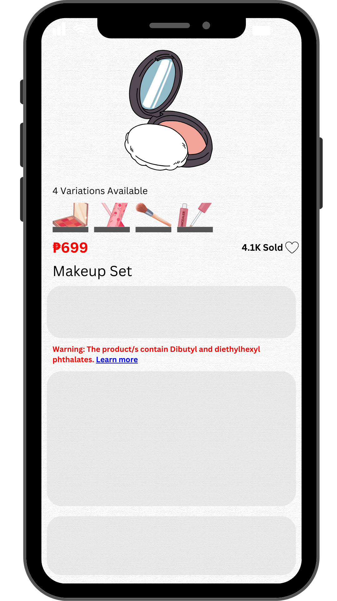
- Add a warning notice listing the toxic chemical compounds the product/s contain. For further information, they may click “Learn more” which redirects them to a credible website detailing the possible dangers of the listed chemical compound/s of the product/s.
  - Most practical option; lists down risky ingredients and informs the user of the risks
  - May be easily lost by the user’s scrolling

Warning Notification

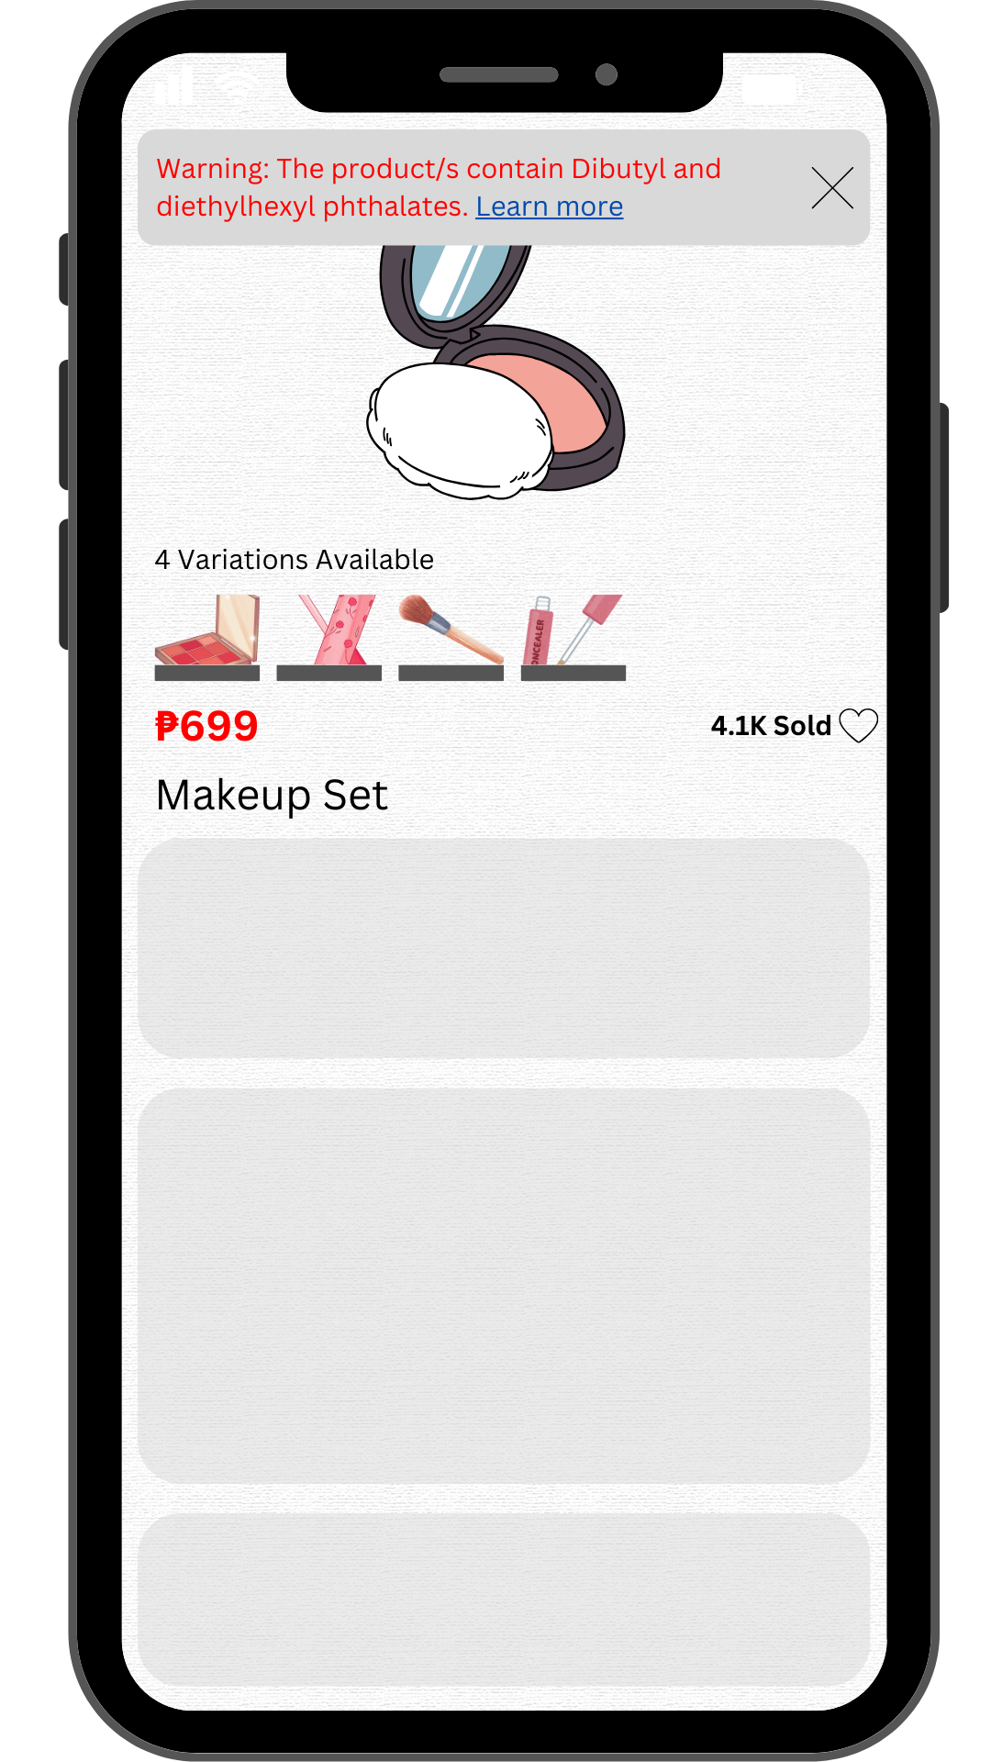
- Instead of adding the warning as part of the description, it appears as a notification whenever a user clicks a product that contains a toxic chemical compound. This makes it less likely for the user to miss the warning, but makes the overall experience intrusive. They may also click “Learn more” which redirects them to a credible website detailing the possible dangers of the listed chemical compound/s of the product/s.
  - Effectively grabs the user’s attention. Notifications have become so ubiquitous in software design, that people will be very quick to interact with the notification given by the app.
  - The notification may get lost among other notifications from other apps in the phone
  - Might become difficult to understand if several toxic ingredients are in a product. Can be handled with case checking (“This product has a few risks…”, “This product has several risks…”, “This product is relatively safe…”, etc.).

List of Risks Button
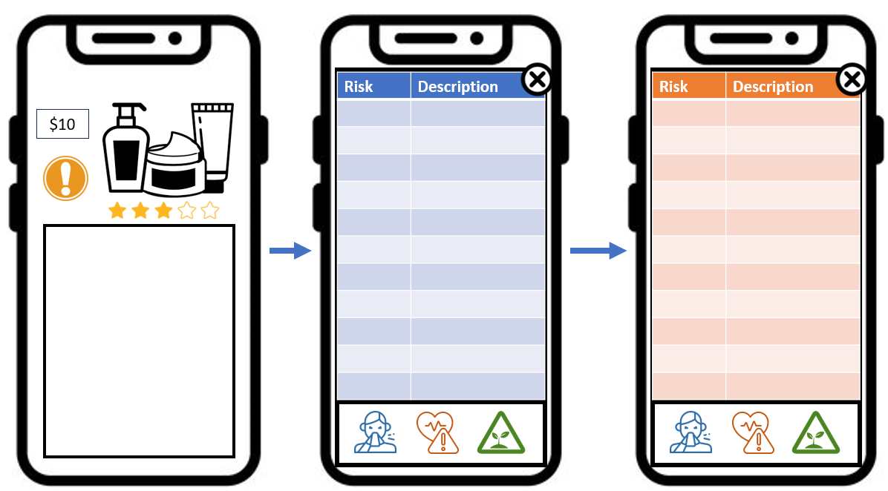
- A button can be added to a shopping application, near the price or the rating (the first thing most people notice and the most important aspect to most shoppers, respectively based on the survey). Once pushed, an interstitial list of risks takes up the screen, but can be exited any time ([X] button in the upper right corner). The list is divided into different categories (allergens, general health risks, environmental risks, waste products, etc.). Tapping an icon lists different types of risky ingredients found in the product.
  - Very comprehensive, informing users of several different risks
  - Requires user-interaction, which may get lost as the user is trying to search for a product they really want
  - Organizing information may be difficult (degree of risk, classification, etc.)
  - May overwhelm a user with a lot of information

